**EXTRACTION FROM VISCERAL SAMPLES**

The organic matters which constitute the bulk portion are destroyed by chemical means to get the active constituents free completely for qualitative and quantitative analysis. The extraction in biological matrices may be carried out by the following methods:

**DRY ASHING METHOD**

* Appropriate amount of macerated tissue or other biological materials is taken in a silica crucible and heated in a Bunsen burner for eliminating the moisture and moderately rescinding the organic material.
* Then, the crucible is kept in a muffle furnace.
* The temperature of the furnace is raised up to 550°C and at this temperature; the burning of the organic matter is made by keeping the silica crucible for about one hour. After the incineration is finished, the crucible is taken out.
* The colour of the residue is to be noted as when warm because in presence of zinc the residue assumes yellow colour while in presence of copper the colour of the residue is slightly bluish green.
* The residue in the silica bowl is boiled with 10 ml. of 4N Hydrochloric Acid and then filtered. The clear acidic solution is tested for metallic poisons such as Copper, Bismuth, Zinc, and Barium etc. by carrying out general group analysis using semi- micro methods, chromatographic and other instrumental techniques.

**WET DIGESTION (ACID DIGESTION) METHOD**

* Adequate amount of biological material or 10 ml. of blood is taken into a Kjeldahl flask and 20 to 40 ml. of Conc.
* Nitric Acid is added to cover the material.
* The flask is gradually heated in flame till the mass begins to liquefy. The heating is continued until the liquefication of the material is complete and that must be completed in the presence of abundant brown fumes of Nitrogen Dioxide in the flask.
* At this point about 20 –30 ml. of concentrated Sulphuric Acid is added and the flask is heated intensely and concentrated Nitric Acid is added drop by drop to the contents of the flask at the rate of about 10 drops per minute so that the atmosphere in the flask must at no times be free from brown fumes.
* Heating should be continued until all organic matter is destroyed and the liquid develops clear and colourless or straw coloured. To find out if the oxidation is complete, the flask is heated without adding any Nitric Acid.
* If there is any unburnt organic matter, the liquid begins to darken and if the digestion is complete, no darkening takes place and the white fumes of Sulphur Trioxide are released.
* In the previous case, the addition of Nitric Acid and heating are continued more till the organic matter is entirely oxidized. Heating is continued for 15 minute more to dispose of the Nitric Acid totally. Then, after cooling, 25 ml. of saturated Ammonium Oxalate solution is added.
* The liquid is boiled until Sulphur Trioxide fumes appear. This confirms complete removal of Nitric Acid. It is then cooled and diluted with an equal volume of water and cautiously relocated to a beaker.
* The beaker is heated to dispense with the remaining Sulphuric Acid. The solution is cooled and diluted with water in such a manner that the strength of acid is about 10%.
* At this juncture a precipitate may be formed which contains the insoluble salts of Lead, Bismuth, Tin, Barium, Strontium or Silver etc.
* The precipitate is filtered off and tested for the metals mentioned above. The filtrate will now contain all other metals except mercury.
* It is subjected to systematic group analysis and quantitative determination subsequently as and when required.

**FRESENIUS AND BABO METHOD**

* The wet digestion method of destruction of organic matter is absolutely not appropriate for Mercury, which may be practically disappeared by volatilization.
* This Fresenius and Babo method is considered to be most acceptable for deliverance of mercury even though there is a likelihood of some loss of mercury by vaporisation.
* A certain amount of biological material is taken in a flask fixed with a reflux condenser. In the event of viscera or other solid material, adequate amount of water is added to make consistency. One third of its volume of chemically pure Hydrochloric Acid and a few grams of solid Potassium Chlorate are added.
* The content is mixed by pulsating. The mixture is heated and small amount of Potassium Chlorate is added time to time and the flask is shaken. Chlorine gas evolves.
* The heating is continued until the contents of the flask becomes a constant straw coloured liquid free from organic matter except some fatty substances in suspension which cannot be oxidized.
* If heating for an hour after the last addition of Potassium Chlorate produces no darkening of the mixture, the oxidation of organic matter may be taken as finished. It takes 4-6 hours to achieve the stage.
* It is filtered and washed with water. The filtrate and washings are collected. Adequate Sodium Sulphite or Bisulphite is added to reduce the surplus chlorine into Hydrochloric Acid. The liquid is warmed on water bath and a current of air is passed to discard the excess Sulphur Dioxide.

**SELECTIVE CHEMICAL TREATMENT**

* In case of presence of Arsenic and Antimony in their higher oxidation state i.e., +5, reduction to +3 states is to be carried out earlier to the chemical treatment.
* A few toxic metals such as Arsenic and Antimony in their specific oxidation state (+5) may be subjected to the reduction process by nascent hydrogen for isolation of metals in matrices like burnt bones, nail, hair in the form of their volatile hydrides i.e., AsH3 and SbH3.
* The method may be carried out by Gutzeit or Marsh-Berzelius method.

**DIRECT SOLVENT EXTRACTION**

* The biological materials i.e., the viscera are mixed with Ammonium Sulphate and made uniform. After addition of Diethyl Ether, the mixture is shaken at pauses and set aside for overnight.
* It is filtered and concentrated and the concentrated extract is cleaned up by passing through a chromatographic column having three sequential stratums of different lengths of 5cm layer of Alumina (top layer), 2.5cm of activated charcoal (middle) and 2.5cm layer of anhydrous Sodium Sulphate (bottom) formerly washed with Ether. The elute is evaporated to dryness as before.

**MICELLAR EXTRACTION IN BIOLOGICAL MATRICES**

* The biological material (viscera) is mixed with Ammonium Sulphate and homogenized.
* After addition of Diethyl Ether, the mixture is shaken at interludes and left over for overnight and filtered.
* The ethereal extract is taken into a separating funnel and Sodium Lauryl Sulphate is added and agitated gradually. On settling, fat in liquid and semi-solid form is separated and taken off from the system.
* The addition of surfactant is continued till all the fatty materials and proteins are separated and settled at the bottom.
* The end-point is specified by a change of dark colour of ethereal layer to colourless. The ethereal extract is shaken with water twice moderately.
* The ethereal layer is collected. In case of emulsion formation, ethereal layer is collected by breaking the emulsion with excess ether and mild stirring.
* The collected ethereal layer in dehydrated over anhydrous Sodium Sulphate to remove traces of water. The ethereal layer is decanted and evaporated to dryness as before.

**MODIFIED STAS-OTTO METHOD**

* Adequate amount of biological material is pulverized and mixed with plenty of rectified spirit in a flask and acidified with Tartaric Acid.
* The mixture is heated on the steam bath for one or two hours with exhaustive shakings at regular pauses.
* The extraction is then allowed to carry on for about 24 hours with steam off. It is then filtered through a corrugated filter paper.
* The filtrate is evaporated and the residue is again extracted with acidulated alcohol in the same way, filtered and washed several times with hot rectified spirit.
* The combined filtrates are evaporated in a porcelain basin on the steam bath to a viscid uniformity. To this thick viscid residue, rectified spirit is added gradually with constant stirring so that insoluble matter may be granulated and not viscous.
* It is warmed with random stirring for about half an hour and filtered. This process is repeated once more and the combined alcoholic extracts are evaporated almost to dryness. The residue is now dissolved in water acidulated with dilute Sulphuric Acid and filtered after about an hour.
* The poisons are consequently dissolved out by the aqueous solution which is relocated to a separating funnel and extracted with an appropriate solvent such as ether, chloroform etc.
* The acid aqueous solution is then rendered alkaline with a solution of Sodium Carbonate or Ammonia, which would release the free base from its salt.
* The alkaline solution is now extracted with chloroform in the similar manner as in the aforementioned stage. It will take up all the alkaloids except for morphine and those weakly basic substances, which are somewhat extracted from the acid solution.

**BASIC TESTS FOR IDENTIFICATION OF COMMON POISONS**

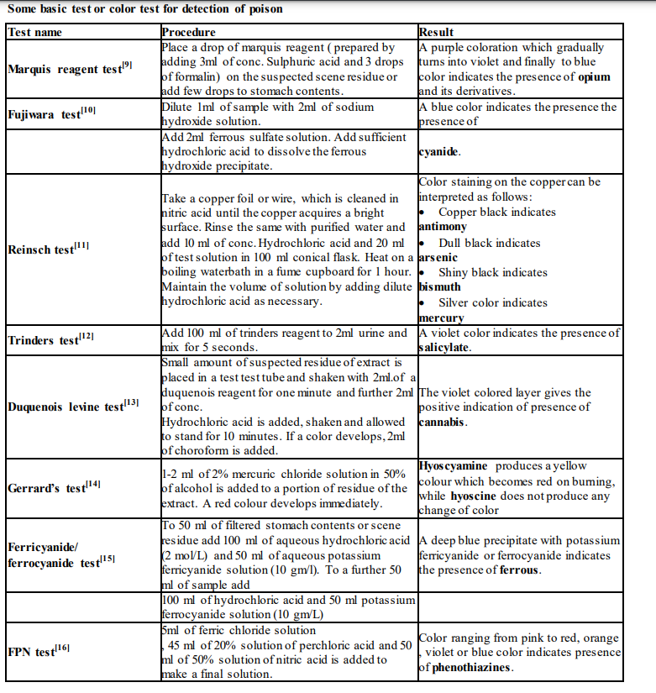

**PHARMACOLOGY**

**INTRODUCTION**

Pharmacology (Gr. pharmakon - a drug or poison, logos - word or discourse) is the science dealing with actions of drugs on the body. In order for a drug to work, it must enter the body and somehow be distributed in such a way that it gets to its site of action. In most cases the site of action is a macromolecular "receptor" located in the target tissue. Most drug effects are temporary, because the body has systems for drug detoxification and elimination.

**DEFINITION**

Pharmacology is the scientific study of the effects of drugs and chemicals on living organisms where a drug can be broadly defined as any chemical substance, natural or synthetic, which affects a biological system.

**SCOPE OF FORENSIC PHARMACOLOGICAL STUDIES**

Forensic Pharmacology offers a unique opportunity to expand the existing knowledge of the drugs, their mechanisms, actions, and its medico-legal impacts. It adds additional dimension to forensic medicine and provides a scope for further research.

**ADME OF DRUGS**

Absorption, distribution, metabolism, and excretion, also known as “ADME,” are the internal processes that describe how a drug moves throughout and is processed by the body.

* **ABSORPTION**

Absorption happens when a drug travels from the site of administration to the systemic circulation system – which provides functional blood supply to all body tissues. The extent of absorption into the bloodstream can be described by bioavailability, which is defined as the fraction of drug that reaches the site of action. For example, drugs that are taken through an oral route of administration often pass through the small intestine and liver, where some amount of the drug is eliminated prior to reaching the bloodstream. This results in a reduction of the amount of drug delivered to the site of action and therefore decreased bioavailability. Drugs that are administered intravenously are delivered directly to the bloodstream and have a bioavailability of 100%. As a result, absorption is not measured for intravenously administered drugs. Food effect PK studies are often conducted for orally administered drugs and may provide information on a drug’s absorption based on the impact of high fat meals, low fat meals, and fasted states. When necessary, studies with gastric acid-reducing agents may also be conducted to determine if a clinically significant drug-drug interaction (DDI) should be anticipated as a result of concomitantly administered drugs that elevate gastric pH. Some factors that can affect the rate and extent of drug absorption include:

* Chemical properties of the drug
* Drug formulation
* Route and site of administration
* Interactions with food or other drugs
* Patient variabilities
* **DISTRIBUTION**

After a drug is absorbed, it is then distributed throughout the body. Distribution describes the process of a drug traveling into different organs and tissues and depends on a multitude of factors including fluid status, blood flow, and chemical characteristics of the drug. Distribution is measured by a fundamental PK parameter known as the volume of distribution. Volume of distribution describes the amount of drug present in the tissues versus in the blood and is important in determining half-life and dosing regimen. Another important consideration to the distribution process is protein binding. When a drug enters the circulatory system, it may become bound to plasma proteins such as albumin, the most abundant plasma protein. Protein binding acts as a “holding station,” rendering the drug pharmacologically inactive while bound. For a drug to achieve its expected pharmacological response, it must be free (unbound to a plasma protein) and reach the site of action at a designated receptor site. Drugs must also be unbound in order to be metabolized.

* **METABOLISM**

Once a drug has been absorbed and is distributed throughout the body, metabolism occurs. Drug metabolism is the process of chemically altering the molecules of a drug, which creates new compounds. The compounds created from this process are known as metabolites. Metabolism may occur in many areas of the body including the gastrointestinal tract, kidneys, and plasma, but the majority of metabolism occurs in the body’s largest internal organ, the liver. In the liver, there are many enzymes that can process drugs via Phase 1 and Phase 2 metabolic pathways. Metabolites formed from Phase 1 reactions are more likely to be pharmacologically active. In contrast, Phase 2 reactions generally render a compound more water soluble and pharmacologically inactive. Although the metabolism of drugs generally decreases their pharmacologic activity, there are some drugs, known as prodrugs, that must undergo metabolism to become active. Prodrugs are often designed to improve certain ADME characteristics of a specific parent drug in order to increase the benefit of the drug for the patient. Cytochrome P450 (CYP) enzymes are responsible for a large percentage of the metabolism of commonly used drugs. CYP-mediated drug metabolism facilitates the elimination of drugs from the body and plays an important role in drug safety and activity. CYPs contribute to variability in drug response and can be impacted by concomitant medications, which can lead to DDIs. Some factors that can affect drug metabolism include:

* Age
* Genetic factors
* Drug interactions
* Organ impairment (e.g., renal or hepatic)
* **EXCRETION**

Any drug that is not eliminated from the body via metabolism is eliminated via excretion. Although drugs can be excreted by a variety of different routes including the liver, lungs, gastrointestinal tract, and skin, the most common pathway of excretion is through the kidneys. When a drug is primarily excreted via the kidneys, impaired kidney (renal) function can significantly affect a drug’s PK. One type of change in the PK of a drug that can occur as a result of impaired renal function is a decrease in the excretion of the drug or a decrease in the excretion of metabolites of the drug. If a drug is not being excreted properly due to renal dysfunction, drug accumulation in the body and potential toxicity can occur. Therefore, in many programs, it is important to characterize PK in renally impaired subjects in order to provide proper dosing recommendations specific to that patient population. Adjusting dosing regimens in patients with renal impairment can help prevent accumulation at steady-state, especially for drugs with a narrow therapeutic index, thus limiting adverse effects in this vulnerable population. Some other factors that can affect drug excretion include:

* Health conditions that impact renal blood flow
* Intrinsic drug properties, such as pH and size
* Genetic variation
* Age